**Guided Capstone Project Report**

Richa Sethi

Our client Big Mountain Resort, a ski resort located in Montana offers spectacular views of Glacier National Park and Flathead National Forest, with access to 105 trails. They recently installed an additional chair lift to help increase the distribution of visitors across the mountain, which increased their operating costs by $1.54MM this season. The resort executives are considering revisiting their pricing strategy, which has traditionally been to charge a premium above the average price of resorts in its market segment. They have a suspicion that Big Mountain is not capitalizing on its facilities as much as it could. Basing their pricing on just the market average does not provide the business with a good sense of how important some facilities are compared to others.

We were provided with data for 330 ski resort across the United States to help us develop a predictive model for pricing strategy that compares the amenities and facilities at resorts across the US for Big Mountain Resort to optimize their prices.

As a starting place, based on our model, it is suggested to increase the ticket pricing from $81 to $90 that would result in revenue increase by $1.58MM, assuming 350,000 visitors annually buying 5 passes each. The increase in ticket price is also justified by Blue Mountain’s amenities being on the upper end compared to other ski resorts in the country, however their ticket price doesn’t show the same trend. (Fig 1).

The dominant top four features that have the largest impact on the ticket pricing are: fastQuads, Runs, Snow Making_ac, vertical_drop (Fig 2).

**Figure 2:** Comparison of Blue Mountain Resort amenities (dashed red line) with other resorts.

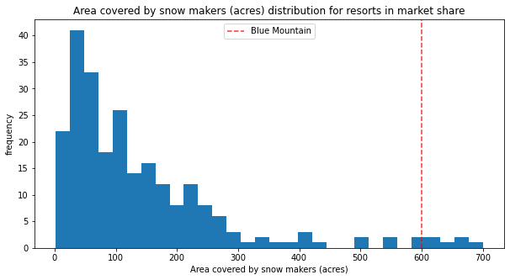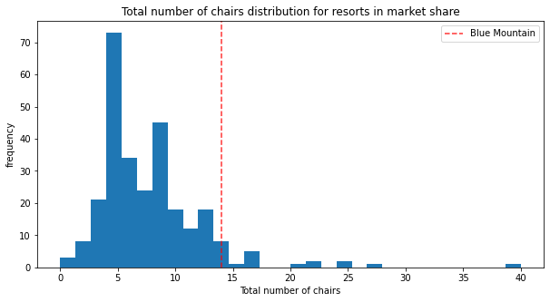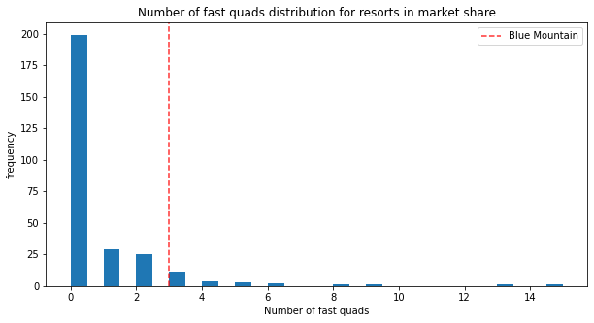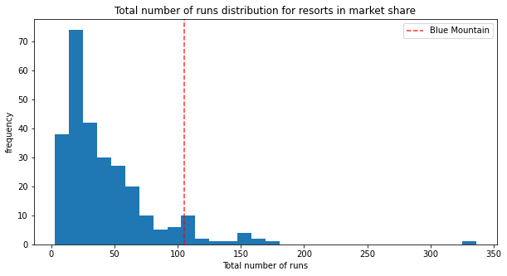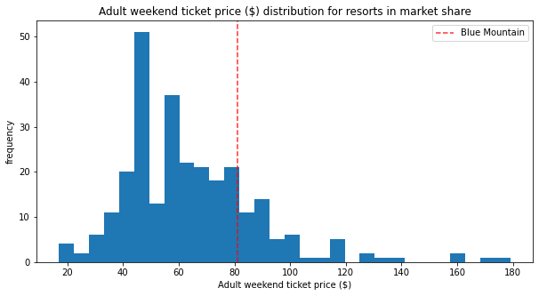

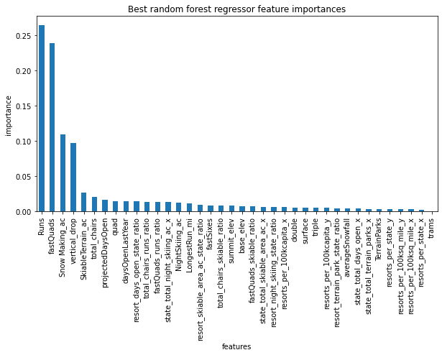

**Figure 2:** Best random forest features in the order of their importance.

Based on the scenarios shortlisted by the management, following are some of the recommendations:

1. Close runs

The model says closing one run would make no difference. Closing 2 and 3 successively reduces support for ticket price and the revenue. If Big Mountain closes down 3 runs, it seems they may as well close down 4 or 5 as there's no further loss in ticket price. However, increasing the closures down to 6 or more leads to a large drop.

1. Add vertical drop

Addition of vertical drop by 150 ft This scenario increases support for ticket price by $1.99

Over the season, this could be expected to amount to $3,48MM, especially because there are quite a few resorts with even higher drops than Blue Mountain (Fig 3).

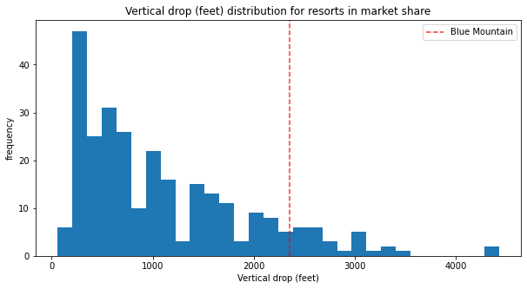

**Figure 3:** Comparison of Blue Mountain Resort vertical drop(dashed red line) with other resorts.

1. Add snow making

Addition of 100 acres of snow making acres This scenario increases support for ticket price by $2.38. Over the season, this could be expected to amount to $416,000